Walk 25 Eardisley and Woods Eaves
Last walked in November 2017

Description. A 7 km (4.3 mile) leisurely walk. No stiles. Quiet country lanes and bridle path, mostly surfaced. Hamlet, historic tree and village on the Black and White Trail. Hereford Times walk of October 2012.
Start. Explorer Map 201 Grid 313492.
Direction from Whitecross roundabout (Turn milometer to zero). Take the (A4111) road towards Kington and at 13.1 miles, at the church in Eardisley, TL. Follow the road and the public bridleway as it bends L around the church, to park in the small car park by Eardisley Millennium Castle Green.

1. Eardisley Parish Church. The church of St Mary Magdalene is famed for its extraordinary carved Norman font, which must be accounted one of the finest fonts in England, if not one of the finest bits of Norman Romanesque architecture of any kind. The font is built like a truncated hour-glass, or a goblet, with a short circular base supporting a wide circular bowl. The carvings are designed to tell a cautionary tale; a sinner saved from the clutches of evil. In the carvings the figure of a man is pursued by a lion (evil), and is saved by Christ from the lion. Christ is accompanied the Holy Spirit in the form of a dove above his shoulder. This scene is also interpreted as a depiction of the Harrowing of Hell. In another part of the design two knights engage in combat. The two figures are thought to represent Lord Drogo of Clifford and his son-in-law, Ralph de Baskerville of Eardisley, who engaged in a real-life combat in a dispute over ownership of land sometime before 1127. The elder knight was killed, but Ralph repented of his actions and became a monk at Gloucester Abbey. It may be Ralph who was responsible for hiring the Herefordshire School of carvers to create the font for Eardisley church. Out of Eardisley Millennium Castle Green car park and TL, walk along the surfaced bridleway, an enclosed lane. You are going to follow this wide and straight bridleway, that continues in the same direction for the next three kilometres, starting by crossing a small bridge before going into open countryside. As you continue on you will see buildings back to your L which are on the site of the old Eardisley wharf and the Hereford, Hay and Brecon Railway ran parallel with our route, 300 metres over to the L. After about 1½ km you go past a mansion on the L, between farm buildings and then a couple of cottages before the path changes into an enclosed aggregated wide grassy track. Continue on to the end of the enclosed track, to go thru a metal gate and into a field. Continue in the same direction, along the L field edge. Go thru a metal gate and along an enclosed farm track to go thru another metal gate onto the road. You are now by the Red Gate Cattery and Boarding Kennels.

2. Red Gate. TR and walk along the country lane for about 1½ km, passing thru the hamlet of Woods Eaves, to reach a road junction at Woods Eaves Farm. Follow the road around to the R, ignore the road on the L as you walk on ahead, with views opening up to the R (south) to Bredwardine and Merbach Hills. Walk on for about ¾ km to go past the next road junction on your L, by an old chapel and a cottage called Great Oak Cottage. (Just up to the L of the chapel is The Great Oak. Find the hollow in the trunk, which once accommodated 28 schoolchildren having a tea party to celebrate its rescue from a fire that they started).

3. Great Oak. Continue along the road to go past the next road junction on your L that’s by a place called Hurstway, and a little further on a cottage called The Laurels. The road continues on to cross a small bridge over a stream and then reaches a T-junction by The Tram Inn in Eardisley. TR and walk along either pavement and go past Eardisley Village Hall to reach the church.

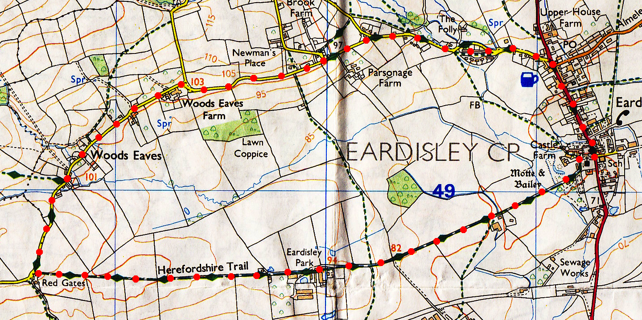

1
2
3

